**The aim of this time series analysis is to formulate time series data to gain knowledge, to fit low dimensional models, and to make predictions. In reality, time series also deals with uncertainty.**

* **Data description**

**Mining**

**About the Mining, Quarrying, and Oil and Gas Extraction sector**

**The mining, quarrying, and oil and gas extraction sector is part of the natural resources and mining super-sector.**

**The Mining sector comprises establishments that extract naturally occurring mineral solids, such as coal and ores; liquid minerals, such as crude petroleum; and gases, such as natural gas. The term mining is used in the broad sense to include quarrying, well operations, beneficiating (e.g., crushing, screening, washing, and flotation), and other preparation customarily performed at the mine site, or as a part of mining activity.**

**North American Industry Classification System**

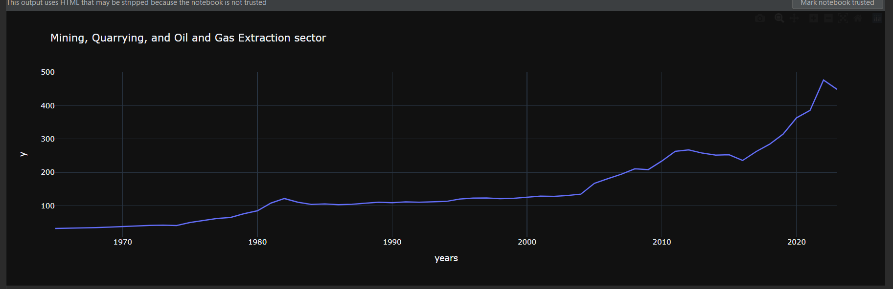

* **Forecast**

**Time series forecasting is the process of analysing time series data using statistics and modelling to make predictions and inform strategic decision-making. It’s not always an exact prediction, and likelihood of forecasts can vary wildly—especially when dealing with the commonly fluctuating variables in time series data as well as factors outside our control**

The STL model is a deterministic model that allows the components to be calculated separately using different methods. It estimates the behaviour of the trend using a LOESS regression, and in turn, calculates the seasonal component by selecting one of more models

* + **Build historical and future datasets**

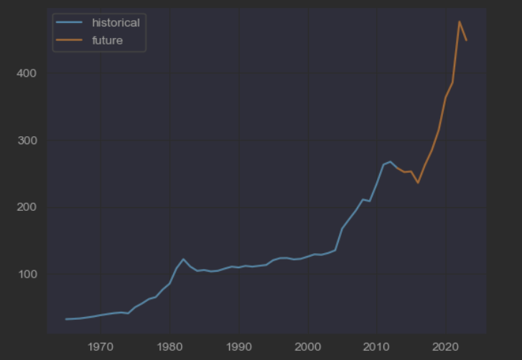

* + Extracting the trend

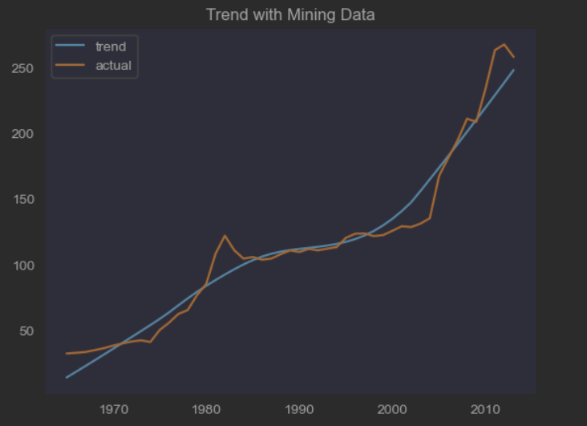

Here we use STL to handle the seasonality and then an ARIMA(1,1,0) to model the depersonalized data. The seasonal component in forecast trend is not present.

* + Model Historical Data

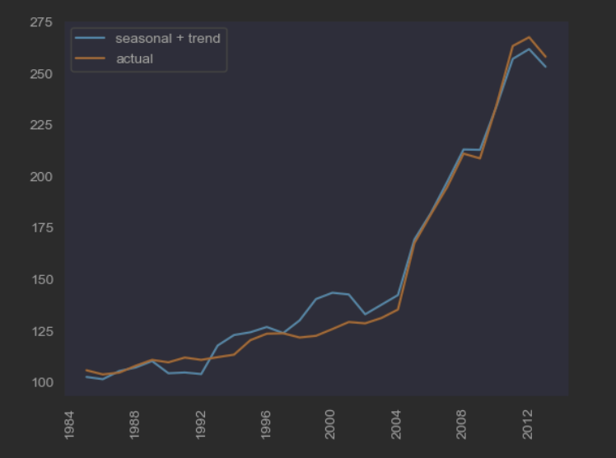

STLForecast simplifies the process of using STL to remove seasonalities and then using a standard time-series model to forecast the trend and cyclical components.

* + Examining Error in Forecast

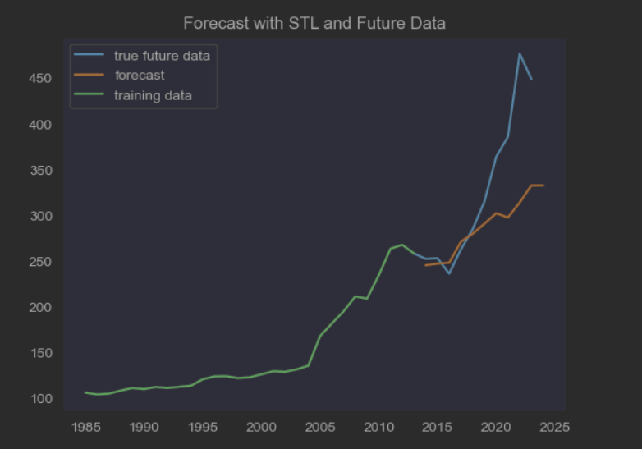

The line plot is showing the observed values compared to the rolling forecast predictions. Overall, our forecasts align with the true values well, showing an upward trend.

The biggest source of uncertainty in the forecast is the potential for future trend changes.

* Stationarity of residuals in a decomposition model

Using the Dickey Fuller test is important as some of our models will expect stationary data. This test gives a basic tool for determining whether a series is stationary outside of the general eye test. We should understand that an increasing or decreasing series is not going to be stationary.

* + Decomposition Model

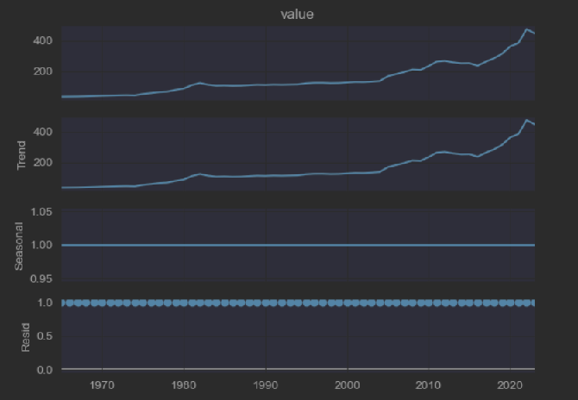

From the above plot we see no presents of seasonality and no big fluctuations of the residuals

* + Check the Model stationarity

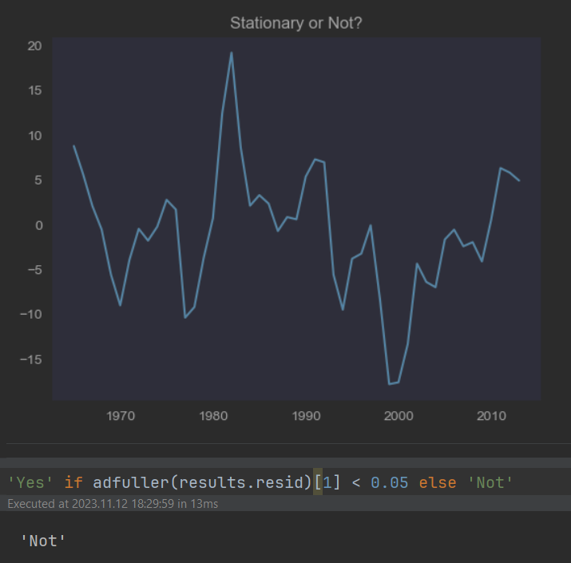

When the original series may not be stationary, we may be interested instead in the differenced data

* + Examining the differenced data

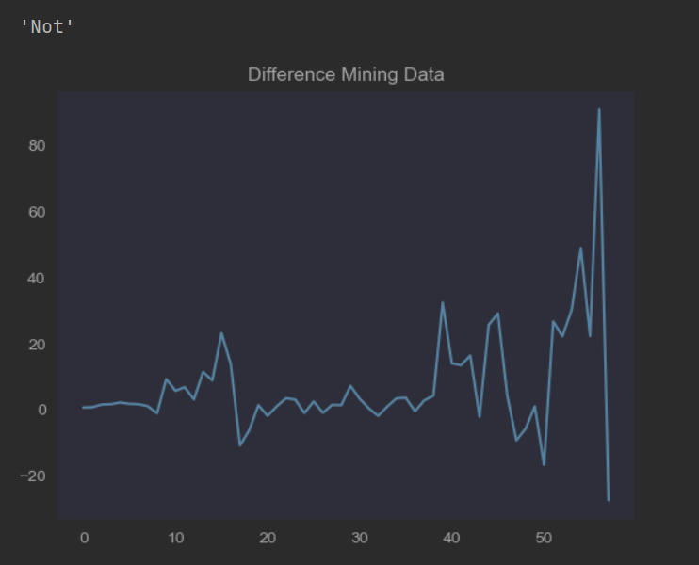

To observe the contrast of non-stationary and stationary data, we can plot the autocorrelation and partial autocorrelation plot on both the original dataset and the differenced dataset

* + Autocorrelation

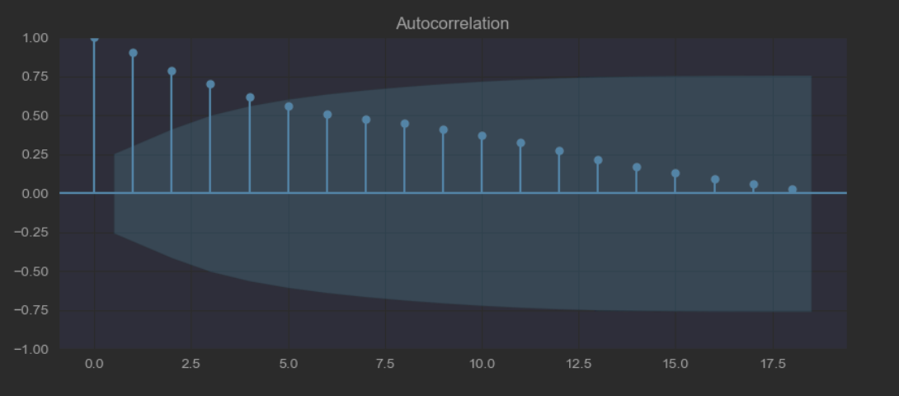

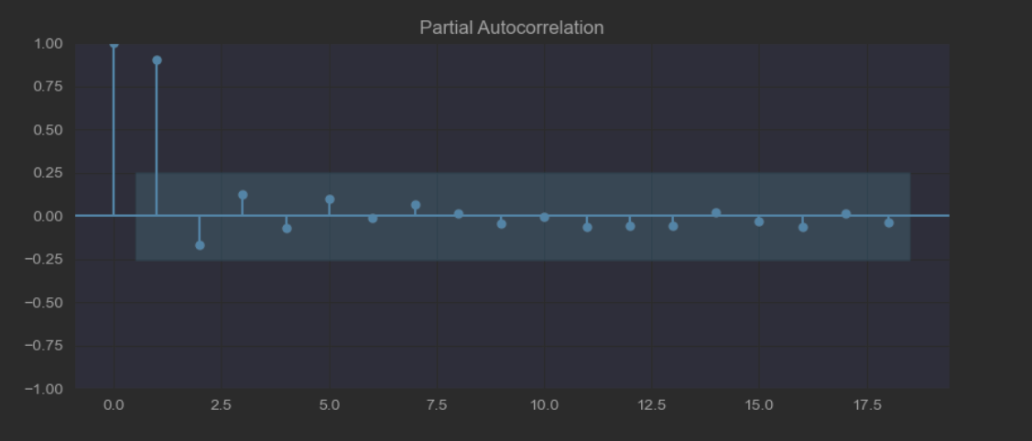

* + Difference Mining data autocorrelation

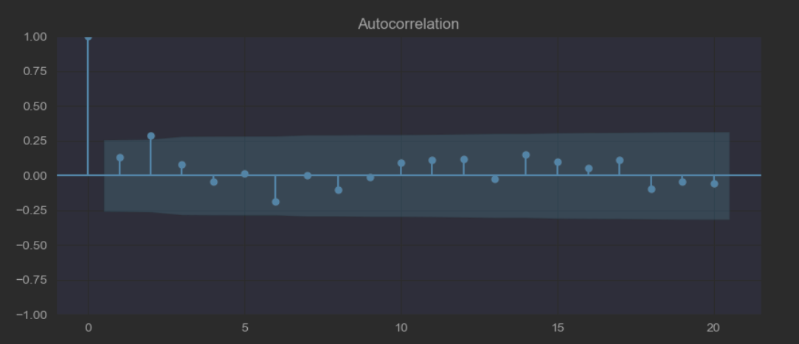

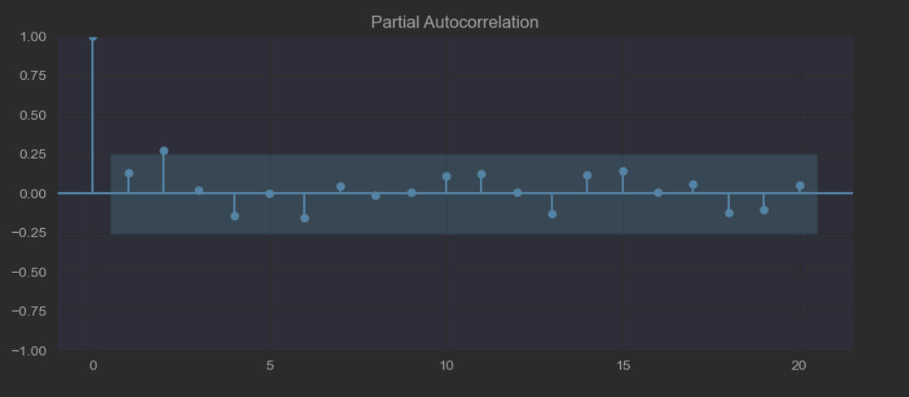

* **Uncertainty**

**Uncertainty exists in time series data. Time series data is known as a stretch of values on a similar scale, indexed by a time that occurs naturally in many application domains such as environmental, economic, finance, etc**

* + **STL Decomposition**

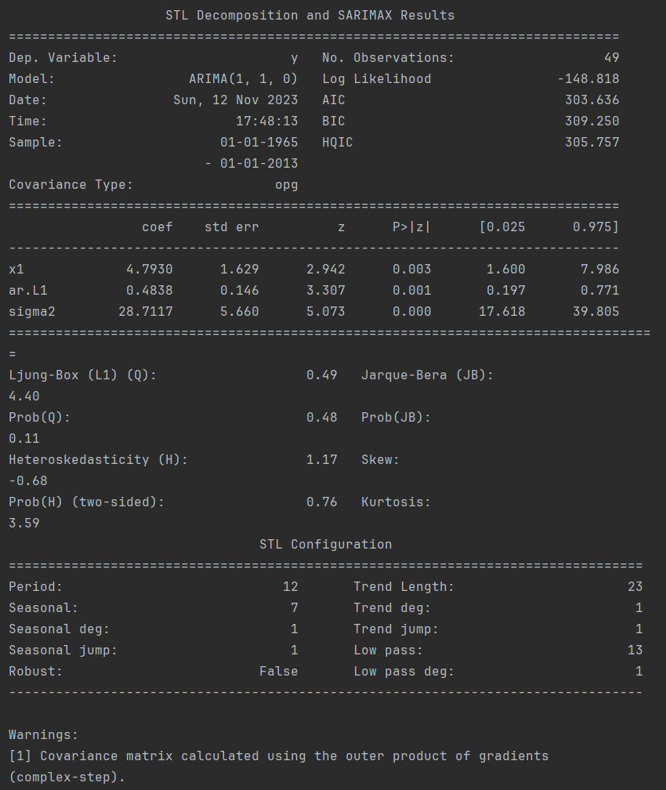

* + STL Forecast Model Error

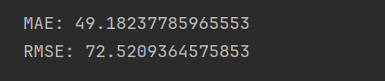

* + Forecast Prediction Interval Error

we will train an ARIMA model, use it to make a prediction, and inspect the prediction interval.

First, we will split the training dataset into a training and test dataset. Almost all observations will be used for training, and we will hold back the last single observation as a test dataset for which we will make a prediction

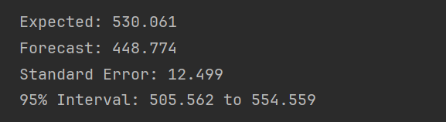

Good wort!

Yes, It is nice approach compact and detailed enough.

Good work and interesting analysis, just curious what could be the STL Decomposition metrics

* Optimal Model

it is usually good practice to perform a simple grid-search on these. Use python algorithm replicating grid-search concept.

